**Excel Assignment 3**

1. **What do you mean by “Relative Cell Referencing” in MS Excel and “Absolute cell referencing”?**

There are two types of cell references: relative and absolute. Relative and absolute references behave differently when copied and filled to other cells. Relative references change when a formula is copied to another cell. Absolute references, on the other hand, remain constant no matter where they are copied.

By default, all cell references are relative references. When copied across multiple cells, they change based on the relative position of rows and columns. For example, if you copy the formula =A1+B1 from row 1 to row 2, the formula will become =A2+B2. Relative references are especially convenient whenever you need to repeat the same calculation across multiple rows or columns.

1. **How to secure an excel workbook, demonstrate it with an example.**

To prevent other users from viewing hidden worksheets, adding, moving, deleting, or hiding worksheets, and renaming worksheets, you can protect the structure of your Excel workbook with a password.

Click Review > Protect Workbook.

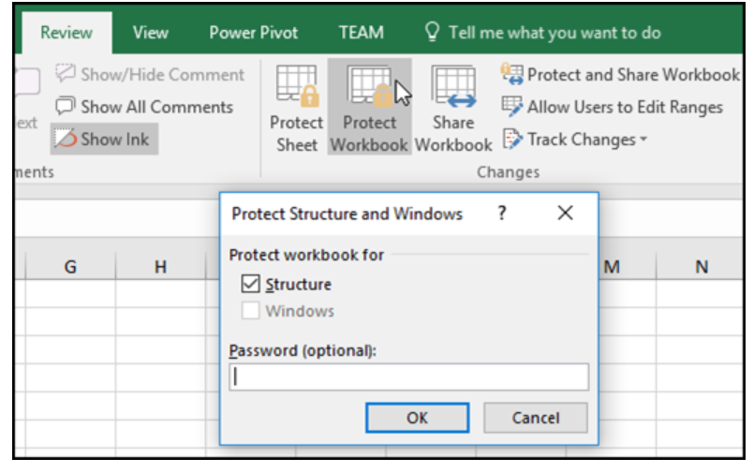

Protect Structure and Windows dialog box

Note: The Windows option is available only in Excel 2007, Excel 2010, Excel for Mac 2011, and Excel 2016 for Mac. Select the Windows option if you want to prevent users from moving, resizing, or closing the workbook window, or hide/unhide windows.

Enter a password in the Password box.

Important: The password is optional. If you do not supply a password, any user can unprotect and change the workbook. If you do enter a password, make sure that you choose a password that is easy to remember. Write your passwords down and store them someplace safe. If you lose them, Excel cannot recover them for you.

Select OK, re-enter the password to confirm it, and then select OK again.

1. **Explain the pivot tables and their implementations.**

Pivot Tables are worksheet tables that let you summarize and analyze your Excel data. Benefits include:

* Ability to recap using any data element and then drill down to review the details.
* Formulas may restrict sorting capabilities or may be corrupted when adding and deleting rows or columns.
* Ability to get a summary or recap of the data rather than scrolling down to find each subtotal.
* Data does not have to be sorted by a particular element in order to get a subtotal for that data element.

1. **Explain lookup in excel with suitable examples.**

The LOOKUP Function is categorized under Excel Lookup and Reference functions. The function performs a rough match lookup either in a one-row or one-column range and returns the corresponding value from another one-row or one-column range.

While doing financial analysis, if we wish to compare two rows or columns, we can use the LOOKUP function. It is designed to handle the simplest cases of vertical and horizontal lookup.

The more advanced versions of the LOOKUP function are HLOOKUP and VLOOKUP.

The formula for the function is as follows:

=LOOKUP(lookup_value, lookup_vector, [result_vector])

Lookup_value (required function) – This is the value that we will be searching. It can be a logical value of TRUE or FALSE, reference to a cell, number, or text.

Lookup_vector (required function) – This is the one-dimensional data that we wish to search. Remember, we need to sort it in ascending order.

1. **What is Data validation, and how to implement it in Excel?**

Use data validation to restrict the type of data or the values that users enter into a cell. One of the most common data validation uses is to create a drop-down list.

1. Select the cell(s) you want to create a rule for.
2. Select Data >Data Validation.

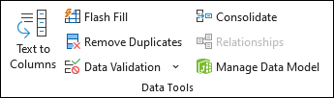

1. On the Settings tab, under Allow, select an option:
   * Whole Number - to restrict the cell to accept only whole numbers.
   * Decimal - to restrict the cell to accept only decimal numbers.
   * List - to pick data from the drop-down list.
   * Date - to restrict the cell to accept only date.
   * Time - to restrict the cell to accept only time.
   * Text Length - to restrict the length of the text.
   * Custom – for custom formula.
2. Under Data, select a condition.
3. Set the other required values based on what you chose for Allow and Data.
4. Select the Input Message tab and customize a message users will see when entering data.
5. Select the Show input message when cell is selected checkbox to display the message when the user selects or hovers over the selected cell(s).
6. Select the Error Alert tab to customize the error message and to choose a Style.
7. Select OK.